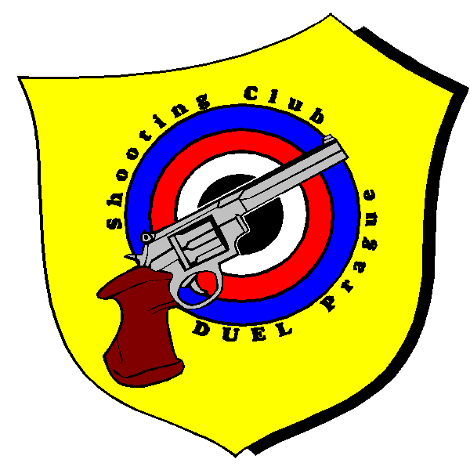
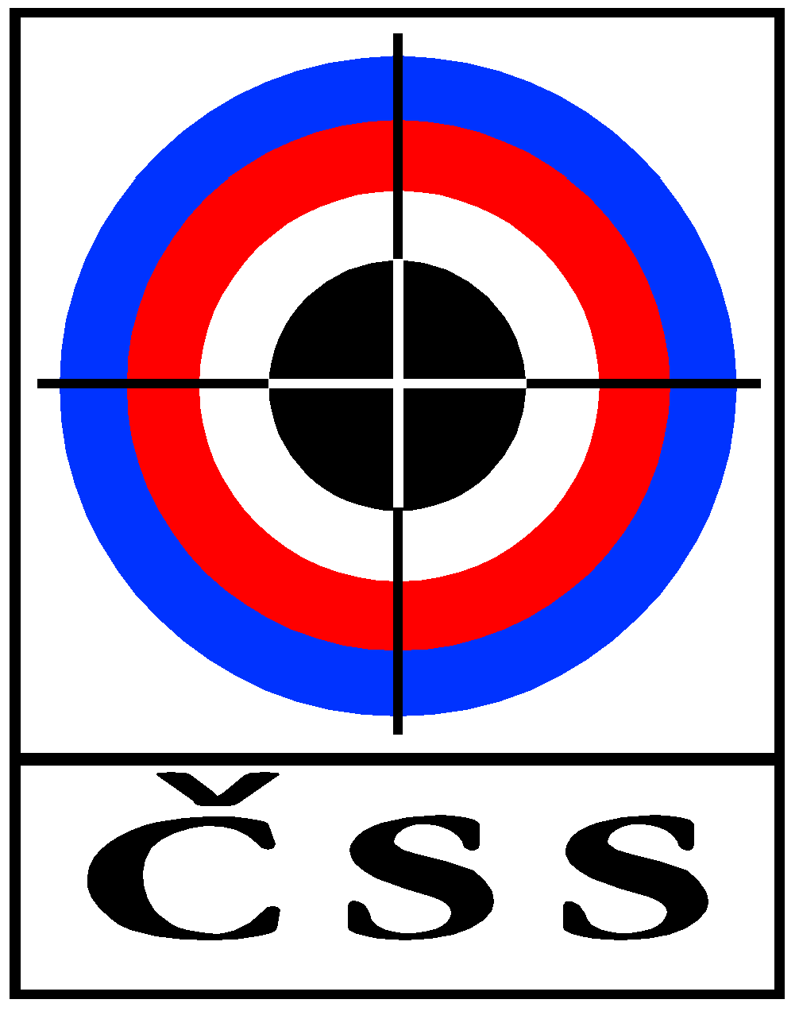

Date: 9. 12. – 10. 12. 2023
Place: Pilsen – Lobzy / CZE

Events: Air Pistol 60, Air Pistol 40, Air Rifle 60, Air Rifle 40
Categories: 1) Men (AP/AR 60)
2) Junior Male (AP/AR 60)
3) Women and Junior Female (AP/AR 60)
4) „Juniors up to 18 years of age“ (AP/AR 40) – no final is held in this category
Programme 9. 12. 2023:
08:00 - Presenation (one hour before start of your relay at the
latest, please, be on time)
09:00 - 10:35 1. Relay AR 60 (Mem, Junior Male)
10:50 - 12:25 2. Relay AR 60 (Men), AP 60 (Junior Male)
12:40 - 14:15 3. Relay AP 60 (Men, Junior Male)
14:30 - 16:05 4. Relay AP 60, AR 60 (Women's and Junior Females)
16:20 - 17:30 5. Relay AP 40, AR 40 (Juniors up to 18 years of age)
17:45 - 18:55 6. Relay AP 40, AR 40 (Juniors up to 18 years of age)

On Saturday: Final AP 60 / AR 60 only in categories 1 and 2 and 3, i.e. AP/AR M,JM,W+JF)
Programme 10. 12. 2023:
08:00 - Presenation (one hour before start of your relay at the
latest, please, be on time)
09:00 - 10:35 1. Relay All
10:55 - 12:30 2. Relay All
12:50 - 14:25 3. Relay All
14:45 - 16:20 4. Relay All
No final is held on Sunday

Start fee: 300,- CZK (14,- Euro) for each start

500,- CZK (20,- Euro) for double start
Applications here - Please send it via e-mail (streit@sskduel.cz) up to November 26.
Jiri Streit, competition director

